RIGHT TRIANGLE TRIGONOMETRY FORMULA SHEET

- Pythagorean Theorem: Used to find a side when 2 sides are given

$a^{2}+b^{2}=c^{2}$ *c must be the hypotenuse

- In a right triangle, to find a side or an angle when a side and an angle are given use:

Sin $θ$ = $\frac{Opposite}{Hypotenuse}$ Cos $θ$ = $\frac{Adjacent}{Hypotenuse}$ Tan $θ$ = $\frac{Opposite}{Adjacent}$

- Rule: In a right triangle the Sin of one acute angle is equal to the cosine of the other acute angle.

Ex. In Δ ABC, if <C is the right angle then Sin A = Cos B

- CoFunctions: Sine and cosine are cofunctions. Think complementary.

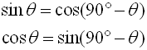

NON RIGHT TRIANGLE FORMULAS

*Remember: little letters are sides; capital letters are angles

- Law of Sines =
Used when given 2 sides and 1 angle trying to get angle opposite given side
OR
given 2 angles and 1 side trying to get side opposite given angle

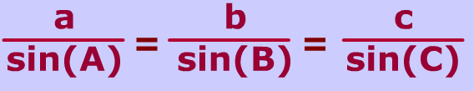

- Area of a Non Right Triangle = Area =$\frac{1}{2}$ ⋅c⋅b⋅sin(A)

*Think $\frac{1}{2}$ ⋅side 1⋅side 2⋅sin of the included angle

